Team Name: piXieduSt and Turtles

Preston McGowan Scott Stroud

## Elevator Pitch:

The piXiduSt and Turtles team utilized the Global Terrorism Databases(GTD) data set to visualize triples pulled from their content.

The team downloaded the Excel formatted data set from GTD and wrote scripts to convert the Excel data into MarkLogic Triples. These triples are then operated on using a semantic enabled service layer. The service layer queries across the indexed dataset using SPARQL and returns JSON formatted search results. Finally the JSON formatted search results are able to be visualized using the piXieduSt and Turtles linked node viewer.

## Example Linked Node Graph

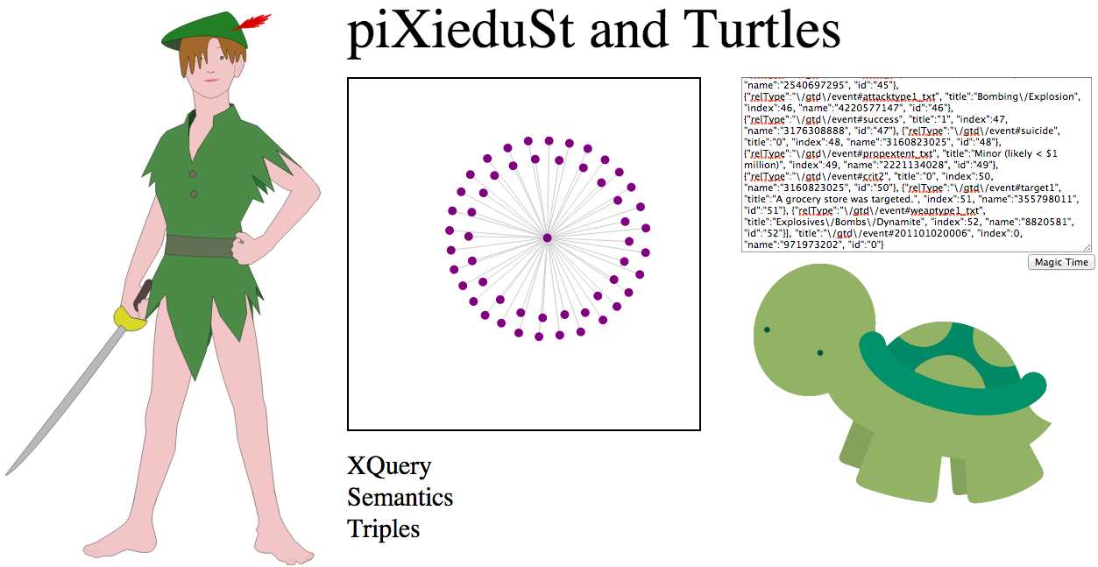

http://HOSTNAME:8008/pdt.xqy

# Appendix: Sample URLs and JSON

**Sample JSON #1:**

http://HOSTNAME:8008/services.xqy?method=properties&event=%22/gtd/event%23201101020006%22

**Result:**

{"children":[{"relType":"\/gtd\/event#multiple", "title":"0", "index":1, "name":"3160823025", "id":"1"}, {"relType":"\/gtd\/event#nperps", "title":"-99", "index":2, "name":"951245332", "id":"2"}, {"relType":"\/gtd\/event#vicinity", "title":"0", "index":3, "name":"3160823025", "id":"3"}, {"relType":"\/gtd\/event#scite2", "title":"BBC Monitoring Former Soviet Union, Shop Blown Up at Night in Russia's Dagestan, No Casualties, LexisNexis Academic, BBC Monitoring Former Soviet Union, January 3, 2011.", "index":4, "name":"3384219429", "id":"4"}, {"relType":"\/gtd\/event#targtype1", "title":"1", "index":5, "name":"3176308888", "id":"5"}, {"relType":"\/gtd\/event#weapdetail", "title":"An improvised explosive device was used in the attack.", "index":6, "name":"2004671823", "id":"6"}, {"relType":"\/gtd\/event#specificity", "title":"1", "index":7, "name":"3176308888", "id":"7"}, {"relType":"\/gtd\/event#date", "title":"2011-1-2", "index":8, "name":"3407069920", "id":"8"}, {"relType":"\/gtd\/event#doubtterr", "title":"0", "index":9, "name":"3160823025", "id":"9"}, {"relType":"\/gtd\/event#nkill", "title":"0", "index":10, "name":"3160823025", "id":"10"}, {"relType":"\/gtd\/event#summary", "title":"01\/02\/2011: On Sunday night at 0045, in Khasavyurt, Dagestan, Russia, unknown assailants detonated an improvised explosive device inside a grocery store. No casualties were reported but the store was destroyed. No group claimed responsibility.", "index":11, "name":"3853366083", "id":"11"}, {"relType":"\/gtd\/event#crit1", "title":"1", "index":12, "name":"3176308888", "id":"12"}, {"relType":"\/gtd\/event#targtype1_txt", "title":"Business", "index":13, "name":"4068616039", "id":"13"}, {"relType":"\/gtd\/event#motive", "title":"The specific motive for the attack is unknown.", "index":14, "name":"1620709284", "id":"14"}, {"relType":"\/gtd\/event#nkillter", "title":"0", "index":15, "name":"3160823025", "id":"15"}, {"relType":"\/gtd\/event#provstate", "title":"Dagestan", "index":16, "name":"211856286", "id":"16"}, {"relType":"\/gtd\/event#dbsource", "title":"ISVG", "index":17, "name":"2863676892", "id":"17"}, {"relType":"\/gtd\/event#claimed", "title":"0", "index":18, "name":"3160823025", "id":"18"}, {"relType":"\/gtd\/event#location", "title":"The attack occurred in a grocery store in Khasavyurt, Dagestan, Russia.", "index":19, "name":"2715237332", "id":"19"}, {"relType":"\/gtd\/event#nkillus", "title":"0", "index":20, "name":"3160823025", "id":"20"}, {"relType":"\/gtd\/event#extended", "title":"0", "index":21, "name":"3160823025", "id":"21"}, {"relType":"\/gtd\/event#natlty1_txt", "title":"Russia", "index":22, "name":"1795569396", "id":"22"}, {"relType":"\/gtd\/event#nwoundte", "title":"0", "index":23, "name":"3160823025", "id":"23"}, {"relType":"\/gtd\/event#nwoundus", "title":"0", "index":24, "name":"3160823025", "id":"24"}, {"relType":"\/gtd\/event#country_txt", "title":"Russia", "index":25, "name":"1795569396", "id":"25"}, {"relType":"\/gtd\/event#nperpcap", "title":"0", "index":26, "name":"3160823025", "id":"26"}, {"relType":"\/gtd\/event#weaptype1", "title":"6", "index":27, "name":"3253738203", "id":"27"}, {"relType":"\/gtd\/event#city", "title":"Khasavyurt", "index":28, "name":"3391767701", "id":"28"}, {"relType":"\/gtd\/event#gname", "title":"Unknown", "index":29, "name":"383736479", "id":"29"}, {"relType":"\/gtd\/event#ishostkid", "title":"0", "index":30, "name":"3160823025", "id":"30"}, {"relType":"\/gtd\/event#longitude", "title":"46.583333", "index":31, "name":"3003756162", "id":"31"}, {"relType":"\/gtd\/event#propextent", "title":"3", "index":32, "name":"3207280614", "id":"32"}, {"relType":"\/gtd\/event#latitude", "title":"43.25", "index":33, "name":"1670477383", "id":"33"}, {"relType":"\/gtd\/event#attacktype1", "title":"3", "index":34, "name":"3207280614", "id":"34"}, {"relType":"\/gtd\/event#weapsubtype1_txt", "title":"Other Explosive Type", "index":35, "name":"249488082", "id":"35"}, {"relType":"\/gtd\/event#country", "title":"167", "index":36, "name":"2540697295", "id":"36"}, {"relType":"\/gtd\/event#property", "title":"1", "index":37, "name":"3176308888", "id":"37"}, {"relType":"\/gtd\/event#crit3", "title":"1", "index":38, "name":"3176308888", "id":"38"}, {"relType":"\/gtd\/event#region_txt", "title":"Russia &amp; the Newly Independent States (NIS)", "index":39, "name":"3400763119", "id":"39"}, {"relType":"\/gtd\/event#weapsubtype1", "title":"17", "index":40, "name":"4107766793", "id":"40"}, {"relType":"\/gtd\/event#propcomment", "title":"The attack destroyed one grocery store.", "index":41, "name":"2874589071", "id":"41"}, {"relType":"\/gtd\/event#nwound", "title":"0", "index":42, "name":"3160823025", "id":"42"}, {"relType":"\/gtd\/event#scite1", "title":"Russia-Eurasia Terror Watch, Grocery Store Bombed, Russia-Eurasia Terror Watch, January 3, 2011, http:\/\/www.retwa.com\/home.cfm?articleDate=3Jan2011.", "index":43, "name":"162553398", "id":"43"}, {"relType":"\/gtd\/event#region", "title":"12", "index":44, "name":"4030337478", "id":"44"}, {"relType":"\/gtd\/event#natlty1", "title":"167", "index":45, "name":"2540697295", "id":"45"}, {"relType":"\/gtd\/event#attacktype1_txt", "title":"Bombing\/Explosion", "index":46, "name":"4220577147", "id":"46"}, {"relType":"\/gtd\/event#success", "title":"1", "index":47, "name":"3176308888", "id":"47"}, {"relType":"\/gtd\/event#suicide", "title":"0", "index":48, "name":"3160823025", "id":"48"}, {"relType":"\/gtd\/event#propextent_txt", "title":"Minor (likely < $1 million)", "index":49, "name":"2221134028", "id":"49"}, {"relType":"\/gtd\/event#crit2", "title":"0", "index":50, "name":"3160823025", "id":"50"}, {"relType":"\/gtd\/event#target1", "title":"A grocery store was targeted.", "index":51, "name":"355798011", "id":"51"}, {"relType":"\/gtd\/event#weaptype1_txt", "title":"Explosives\/Bombs\/Dynamite", "index":52, "name":"8820581", "id":"52"}], "title":"\/gtd\/event#201101020006", "index":0, "name":"971973202", "id":"0"}

**Sample JSON #2:**

**http://HOSTNAME:8008/services.xqy?method=events&relType=%22/gtd/event%23country_txt%22&name=%22Iraq%22**

**Result:**

{"children":[{"relType":"\/gtd\/event#country_txt", "title":"\/gtd\/event#201101010003", "index":1, "name":"2628665238", "id":"1"}, {"relType":"\/gtd\/event#country_txt", "title":"\/gtd\/event#201101010004", "index":2, "name":"2644151101", "id":"2"}, {"relType":"\/gtd\/event#country_txt", "title":"\/gtd\/event#201101020001", "index":3, "name":"894543887", "id":"3"}, {"relType":"\/gtd\/event#country_txt", "title":"\/gtd\/event#201101020002", "index":4, "name":"910029750", "id":"4"}, {"relType":"\/gtd\/event#country_txt", "title":"\/gtd\/event#201101020003", "index":5, "name":"925515613", "id":"5"}, {"relType":"\/gtd\/event#country_txt", "title":"\/gtd\/event#201101020004", "index":6, "name":"941001476", "id":"6"}, {"relType":"\/gtd\/event#country_txt", "title":"\/gtd\/event#201101020005", "index":7, "name":"956487339", "id":"7"}], "title":"Iraq", "index":0, "name":"1333598278", "id":"0"}

# Appendix: Resources

Global Terrorism Database (GTD)

<http://www.start.umd.edu/gtd/contact/>

Code Flower

<https://github.com/fzaninotto/CodeFlower>

D3

<https://github.com/mbostock/d3>